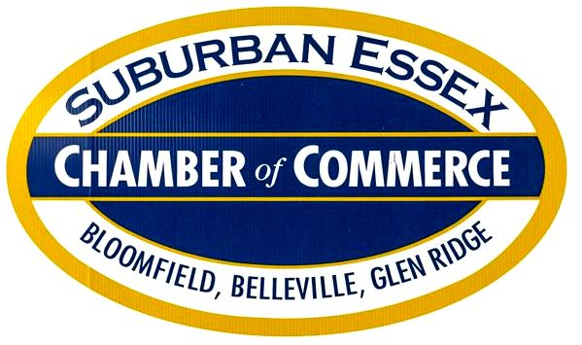  256 Broad Street, Bloomfield, NJ 07003  suburbanessexchamber.com  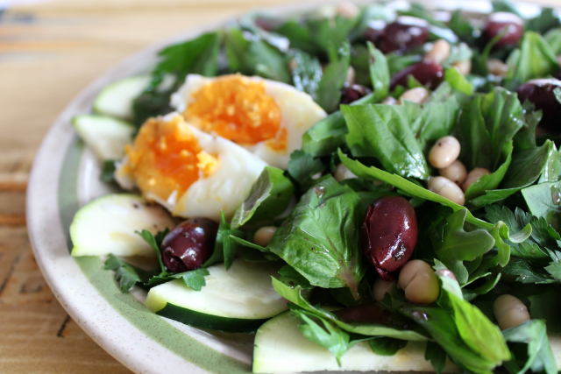  HAPPY HEALTHY HOUR  Please join us!  Brookdale Tavern & Kitchen  1099 Broad Street, Bloomfield  Thursday, April 11, 2019  5:30 – 7 PM  $25 pp to include Salad Bar w/Protein and  Vegetable Wraps (Cash Bar)  Call 973-748-2000 for Reservations!  Thank you!  Invite and Show a Friend the Value of Chamber Membership! | Guest Speakers  A T.E.A.M. Approach Chiropractic and Physical Therapy Center  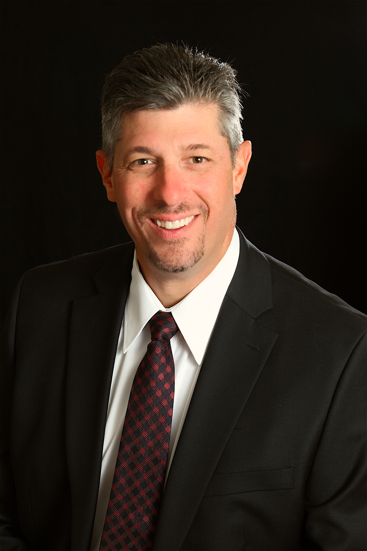  Robert A. Ruffalo PT, DC, CCSP  Nancy Alario PT, DPT  tHE DOMINO EFFECT OF HEALTH AND WELLness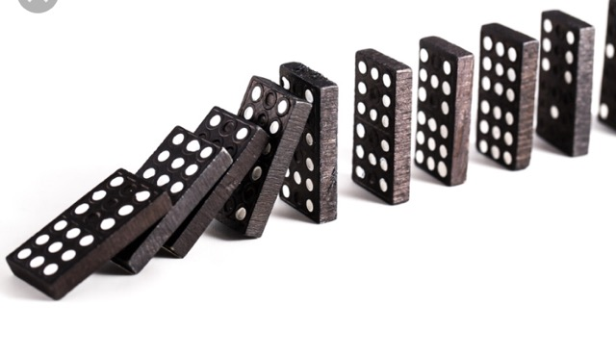  ~ bASIC nUTRITION  ~ Clean Eating  ~ Detox  ~ Movement  ~ Sleep  ~ Recovery

